🌐 Lesson 9: Networks, Communication Systems, and Network Infrastructure

🏛️ Module Foundations & Digital Communication
📖 Lexicon & First Principles
• Computer Network – An interconnected system comprising two or more computational devices linked via physical cabling or wireless telecommunication channels to facilitate resource sharing and information interchange.
• Digital Communications – The systematic process wherein two or more computational systems transfer structured data, operational instructions, and contextual information.
• Transmission Medium – The physical or electromagnetic path bridging a transmitting node and a receiving terminal.

⤷ Fundamental Purpose of Networking:
Eliminates standalone data silos by enabling distributed resource sharing across four critical asset classes:
↳ Hardware Sharing: Centralising costly physical peripherals (e.g., laser printers, scanners, storage arrays).
↳ Software Sharing: Running centralised enterprise programmes and shared network applications.
↳ Data & Information Sharing: Granting multi-user access to collective databases, files, and corporate assets.
↳ Global Interconnectivity: Unifying heterogeneous local nodes into planetary communication grids via the Internet.

⚙️ Operational Flow of a Communication System
Every telecommunication transaction requires four interdependent components operating in unison:
Sending Device ⟶ Communications Device ⟶ Transmission Medium ⟶ Communications Device ⟶ Receiving Device

⤷ Four Primary System Components:
↳ Sending Device: An endpoint (e.g., workstation, mobile phone, server) that initiates an explicit instruction to transmit payload data, control signals, or programmatic commands.
↳ Communications Device: Hardware that converts, modulates, or routes data between the host system and the physical channel (e.g., modems, network interface cards, routers, wireless access points).
↳ Transmission Media (Channel): The physical conduit or electromagnetic carrier wave over which modulated signals propagate.
↳ Receiving Device: The destination node configured to accept, demodulate, and process the arriving packet stream.

🏢 Network Classification: Context, Scope, and Medium

🏠 Home Networks vs. 🏢 Enterprise Networks
Attribute / Parameter | 🏠 Home Network Environment | 🏢 Enterprise / Business Network
Primary Objective | Convenience, peripheral pooling, recreational sharing | Throughput, fault tolerance, data governance, continuity
Internet Access | Pooled access over a single shared consumer gateway | Multi-homed, load-balanced redundant leased lines
Asset Distribution | Ad-hoc file sharing (e.g., family photographs, media) | Role-based relational databases and access-controlled file servers
Peripheral Use | Shared consumer-grade printer or domestic smart hub | Enterprise print servers and multifunction imaging centres
Dedicated Roles | Peer devices and entertainment consoles (online gaming) | Centralised, automated off-site backups and disaster recovery

🛡️ Organisational Network Segments: Intranet, Extranet, and VPN
⤷ Intranet:
An internal, strictly closed enterprise network that leverages standard Internet communication protocols (e.g., HTTP, TCP/IP) to distribute proprietary information to authorized internal personnel exclusively.
→ Example: An internal corporate portal hosting employee payroll records and standard operating procedures (SOPs).

⤷ Extranet:
A controlled, semi-private extension of an intranet allowing authenticated external stakeholders (such as vetted vendors, supply-chain partners, and enterprise customers) limited access to internal resources.
→ Example: A supplier portal permitting third-party freight carriers to monitor real-time warehouse inventory levels.

⤷ Virtual Private Network (VPN):
An encrypted overlay tunnel configured across a public telecommunication medium (e.g., the Internet) to securely bridge a remote host or branch office into a private enterprise intranet.
↳ Cryptographic Tunnelling: Employs point-to-point packet encryption to ensure payload confidentiality and header integrity over untrusted transit networks.
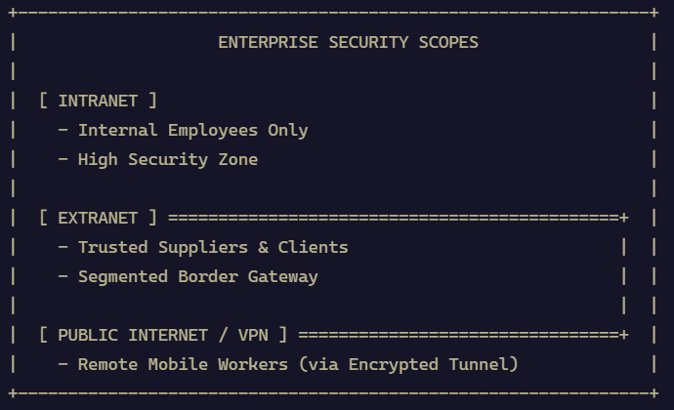

🔌 Physical Media: Wired vs. Wireless Topography
⤷ Wired Networks (Guided Media):
Physical transmission pathways utilising metallic cabling (twisted-pair copper, coaxial) or optical conduits (fibre-optic strands) through walls, conduits, and sub-flooring.
↳ Operational Merits: Superior transmission velocity, negligible packet jitter, and elevated security (requires physical wiretapping to intercept signals).

⤷ Wireless Networks (Unguided Media):
Broadcast communications propagating radio frequency (RF) or infrared (IR) waveforms through the atmosphere.
↳ Operational Merits: Superior physical mobility and expedited deployment; compromised by vulnerability to interception and physical RF attenuation.

⤷ Cellular / Mobile Telephony Networks:
Radio networks distributed over geographical cells, each served by at least one fixed-location transceiver base station.
↳ Generational Milestones: Transition from legacy 3G voice/data systems to high-throughput 4G LTE, through to ultra-low latency, high-density 5G NR (New Radio) deployments.

⤷ Communications Software:
System and application utilities that establish socket connections, arbitrate transport layer handshakes, police congestion, and render high-level user interfaces for human interaction.

📐 Network Topologies
📖 Lexicon & First Principles
• Network Topology – The geometric and physical or logical arrangement of nodes, terminating links, and peripheral connections across a telecommunication fabric.
• Single Point of Failure (SPOF) – A singular hardware element or transmission path whose functional cessation triggers the catastrophic failure of the entire systemic whole.

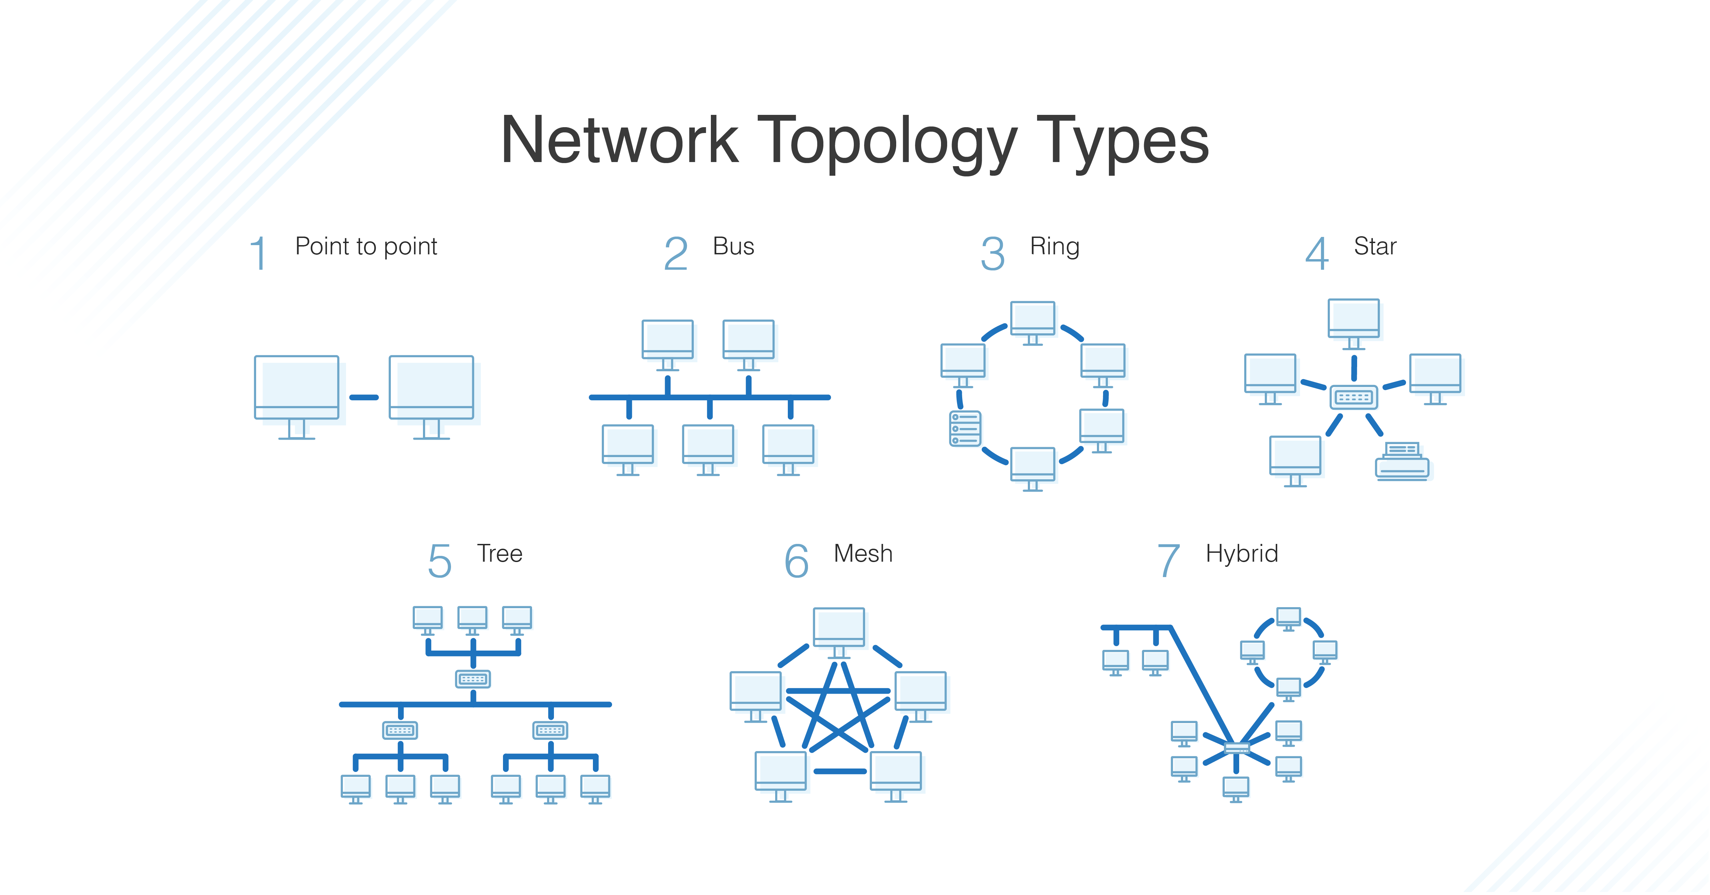

1. 🚌 Bus Topology
⤷ Architecture: All network nodes attach directly to a single shared central backbone cable (the "bus") terminated at both extremities.
⤷ Vulnerability: Exhibits a severe single point of failure; if the central trunk line breaks, all network communication instantly collapses.

2. 🕸️ Mesh Topology
⤷ Architecture: Nodes maintain direct point-to-point physical links with peer nodes, dynamically routing traffic around hardware faults.
↳ Full Mesh: Every computational device connects directly to every other individual device on the subnet. Maximum fault tolerance; exponential cabling overhead:
Total Links = [n(n − 1)] / 2
↳ Partial Mesh: Redundant links connect high-traffic nodes, whereas secondary peripheral nodes connect to only one or two nodes to balance cost and resilience.
⤷ Resilience Factor: If a given node or transmission path fails, packet traffic reroutes dynamically across surviving alternative lines without systemic disruption.

3. 💍 Ring Topology
⤷ Architecture: Devices are interconnected serially in a closed, circular loop where data frames travel unidirectionally (or bidirectionally in dual-ring setups) from node to neighbouring node.
⤷ Vulnerability: If an intermediate workstation suffers hardware failure or a link is severed, the continuous loop breaks and all communication across the entire ring ceases. Largely obsolete in modern local networks.

4. ⭐ Star Topology
⤷ Architecture: Every individual network device connects via a dedicated point-to-point link directly to a central concentrator, such as a multiport switch or server.
⤷ Failure Dynamics:
↳ If an individual workstation or cable link fails: Only the affected node drops offline; the rest of the network operates undisturbed.
↳ If the central switch/hub fails: The entire subnet drops offline (the central hardware is an absolute SPOF).

5. 🌲 Tree (Hierarchical) Topology
⤷ Architecture: Integrates multiple individual star networks linked together along a central linear bus backbone.
⤷ Practical Deployment: The predominant design pattern utilised across corporate campuses, departmental enterprises, and educational institutions.

🏛️ Network Architectures & Geographic Classifications

🖥️ Client/Server Architecture
⤷ Operational Dichotomy:
↳ Server: A high-specification, dedicated host computer provisioned to coordinate network traffic, manage centralized authentication databases, and serve operational resources.
↳ Client: A dependent endpoint (workstation, thin client, smartphone) that relies upon and queries the central server to obtain files, data, and access privileges.

⤷ Administrative Governance: Client/server infrastructures are universally policed, configured, and maintained by a professional Network Administrator.

🗺️ Geographic Classifications
[ BAN ] ---> [ PAN ] ---> [ WLAN / LAN ] ---> [ MAN ] ---> [ WAN ]
(Body) (Personal) (Building/Room) (City) (Planetary)

🔢 Taxonomy of Network Scale
1. BAN (Body Area Network) – Wearable or medically implanted sensor units operating in, on, or adjacent to the human body (e.g., biometric biosensors, insulin delivery monitors).
2. PAN (Personal Area Network) – Centred around an individual within an intimate perimeter, typically under 10 metres (e.g., Bluetooth pairing of a handset with headphones or peripheral input devices).
3. LAN (Local Area Network) – Connects nodes within a limited, contiguous geographic space (a room, home, single office, or building).
4. WLAN (Wireless Local Area Network) – A LAN that leverages high-frequency radio waves (Wi-Fi) rather than physical cabling to bridge endpoints to the network backbone.
5. MAN (Metropolitan Area Network) – Spans a broader municipal area or distinct urban district (e.g., municipal Wi-Fi networks, regional cable television delivery systems).
6. WAN (Wide Area Network) – Spans massive geopolitical boundaries, encompassing states, nations, or the entire globe (e.g., the Internet itself, bank ATM grids).

📡 Network Standards and Protocols
📖 Lexicon & First Principles
• Standard – A formalised, universally agreed-upon industrial specification or technical framework codified by international standards bodies (e.g., IEEE, ISO).
• Protocol – A strict syntactic and semantic set of procedural rules governing how data must be packaged, addressed, transmitted, and error-checked across a communication link.

📊 Comparative Analysis: Protocols and Standards
Standard / Protocol | Formal Type | Operational Mechanism & Practical Implementation | Nominal Spatial Range
Bluetooth | Protocol | Short-range RF communication for pairing consumer peripherals (headsets, input devices). | Short (≤ 30 ft / 9 m)
IrDA | Standard | Infrared light pulses; requires strict line-of-sight propagation (television remote controls). | Very Close / Direct Sight
LTE | Standard | Long-Term Evolution; cellular broadband data framework transmitting over cellular carrier frequencies. | Metropolitan / Cellular Cell
NFC | Protocol | Near Field Communication; ultra-close electromagnetic induction for contact-free mobile point-of-sale transactions. | Sub-centimetre (≤ 4 cm)
RFID | Protocol | Radio Frequency Identification; queries passive or active transponders via antennas (toll tags, pet tracking). | Inches to Metres
TCP/IP | Protocol | Transmission Control Protocol / Internet Protocol; the foundational routing and delivery suite of the global Internet. | Global / Universal
Token Ring | Standard | Deterministic LAN architecture utilising circulating electronic tokens to arbitrate packet transmission priority. | Local Area Network
UWB | Standard | Ultra-Wideband; low-energy, pulse-based radio spectrum delivering short-range, massive bandwidth (inventory tracking). | Short Range (< 10 m)
Wi-Fi | Standard | IEEE 802.11 standards family deploying TCP/IP over high-frequency wireless spectra (hotspots, office WLANs). | Medium (30–100 m)

⚙️ Network Connection Hardware
⤷ Node: Any addressable computational terminal, peripheral, or communication component connected into a network fabric.
⤷ Hub (Layer 1): A primitive, non-intelligent hardware concentrator that blindly broadcasts incoming data packets across every single physical port, precipitating severe packet collisions.
⤷ Switch (Layer 2): An intelligent multiport device that inspects arriving frames, matches the destination hardware address (MAC), and forwards traffic exclusively to the intended recipient port.
⤷ Router (Layer 3): An intelligent internetworking device that examines IP addresses, determines optimal metric paths across disparate networks, and routes packets between them.
⤷ Modem (Modulator-Demodulator): Translates digital computational square-waves into analog waveforms suitable for transmission media, and vice-versa.
↳ Digital Modem: Transmits and receives data directly across modern digital communication lines.
↳ Cable Modem: Modulates high-speed broadband signals over coaxial Community Antenna Television (CATV) lines.
↳ DSL Modem: Direct Digital Subscriber Line; transmits data over copper telephone wiring without interrupting voice service.
↳ ISDN Modem: Integrated Services Digital Network; early standard for digital packet transport across traditional copper phone infrastructure

🛠️ Step-by-Step Implementation: Network & Peripheral Deployment

📶 Deploying a Home or Small Office Wireless Network
[ STAGE 1: Physical Link ]
Acquire modem/router gateway -> Connect physical WAN port to active ISP feed
│
▼
[ STAGE 2: Logical Configuration ]
Access administrative GUI -> Broadcast distinct SSID -> Select WPA2/WPA3 key
│
▼
[ STAGE 3: Client Authentication ]
Activate device Wi-Fi -> Enumerate SSIDs -> Select target -> Input security key

- Step 1 — Upstream Gateway Connection: Acquire a consumer modem or integrated wireless router; connect the device's WAN port directly to the physical Internet Service Provider (ISP) termination point.
- Step 2 — Access Point Parameterisation: Access the administrative dashboard, enable the internal RF radio transceivers, define a unique Service Set Identifier (SSID / Network Name), and establish robust pre-shared encryption credentials (wireless network security key).
- Step 3 — Client Host Authentication: Enable the wireless radio on the client computer or mobile device, scan for surrounding RF signals, select the configured SSID, and enter the established security key to complete the network handshake.

🖨️ Wireless Network Printer Integration
⤷ Key Advantages:
↳ Eliminates dedicated printer cabling; enables concurrent access across multiple desktop clients, mobile terminals, and portable laptops.
↳ Enables direct mobile document processing via vendor-specific mobile applications.
⤷ Step-by-Step Setup Protocol:
1. Position the wireless printer on a stable surface within the unobstructed transmission range of the local wireless access point.
2. Boot the device, access the onboard digital configuration menu, and navigate to Network Settings.
3. Scan the local RF environment, select the appropriate office SSID, and input authentication credentials.
4. Deploy the manufacturer's printer driver or administrative application across all participating client hosts.

📡 Optimising Wireless Signal Coverage and Propagation
💡 Practical Signal Optimization Protocol
• Antenna Articulation – Fully extend and align external dipole antennas perpendicularly to maximize radiation pattern coverage.
• High-Gain Upgrades – Replace weak omnidirectional factory antennas with aftermarket high-gain signal boosters.
• Centralised Spatial Placement – Position the wireless router in a high, central geographic location within the building, away from dense masonry walls, large metal structures, and 2.4 GHz RF interference sources (e.g., microwave ovens).
• Deploy Boosters / Repeaters – Install a wireless range extender (repeater) mid-way between the router and signal dead zones to amplify and rebroadcast attenuated waveforms.
• Hardware Upgrades – Retire and replace obsolete routing hardware when underlying routing engines or radio transmitters prove insufficient for client density.

🛡️ Network Security, Malicious Threats, and Defence Mechanisms
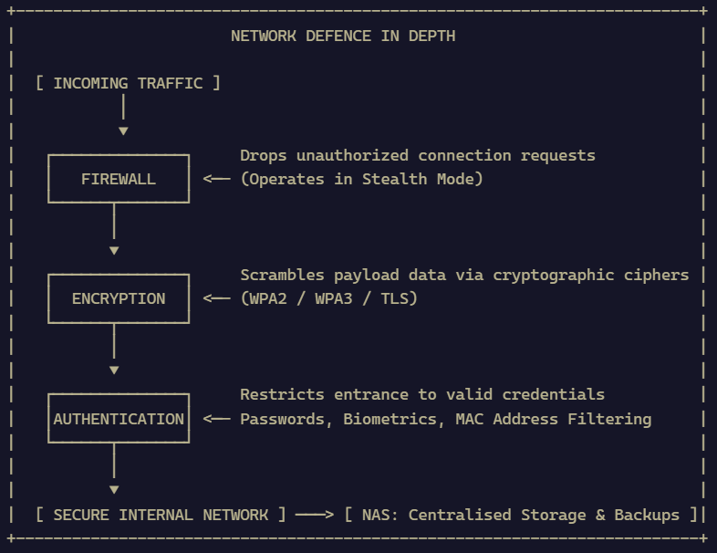

🦠 Threat Taxonomy: Malicious Software (Malware)
Threat Vector | Modus Operandi & Damaging Consequences
Adware | Aggressively renders unwanted marketing materials, banners, and intrusive pop-up advertisements across the host operating system.
Spyware | Silently intercepts, logs, and transmits sensitive user telemetry, browsing histories, and confidential personal data to a remote adversary without user consent.
Virus | Parasitic code that infects legitimate executable files, altering system configurations and corrupting or deleting local data stores; requires human execution to propagate.
Worm | Self-replicating, autonomous malicious software that spreads rapidly across network paths without requiring human intervention or host files.
Trojan | Masquerades as a benign, desirable programme or document; executes destructive payloads behind the scenes once executed by the deceived operator.
Ransomware | Cryptographically locks the victim's filesystem, rendering critical documents and programmes inaccessible until an extortion demand (ransom) is remitted.
Rootkit | Infiltrates the host kernel to seize persistent administrator-level (root-level) execution privileges while deliberately concealing its footprint from system monitoring tools.

🧱 Defensive Mechanisms & Storage Infrastructures
⤷ Network-Attached Storage (NAS): A dedicated, high-capacity hardware appliance connected directly to a network segment to provide centralized data storage, access-controlled file sharing, and automated data backups for both small and enterprise environments.
⤷ Data Encryption: The mathematical scrambling of plain-text data into unreadable ciphertext utilizing complex cryptographic algorithms, ensuring interception across an untrusted channel yields unreadable noise.

⤷ Authentication & Identity Verification:
↳ Credential-Based: Standard combinations of unique usernames matched against strong passwords.
↳ Biometric Verification: Validates identity via the mechanical analysis of unique physiological traits (e.g., optical iris patterns, biometric fingerprint scans).

⤷ Firewalls: A dedicated hardware appliance or software layer establishing a filtering blockade between trusted internal subnets and untrusted external networks (the Internet).
↳ Stealth Mode Configuration: Configures the gateway interface to drop unsolicited ICMP ping requests and port scans, effectively rendering the network node invisible to unauthorized reconnaissance probes.

⤷ Wireless Access Audit Protocol:
1. Authenticate into the router's administrative dashboard using strong, non-default credentials.
2. Inspect the active Dynamic Host Configuration Protocol (DHCP) table and count the list of connected MAC / IP devices.
3. Re-secure the perimeter immediately if unauthorized nodes appear: reset the WPA security key, terminate unauthorized active sessions, and restrict ingress via hardware MAC address filtering.

⚖️ Professional Ethics and Responsibilities
🔢 Tenets of the Network Professional's Code of Conduct
Certified network engineers and administrators bear rigorous fiduciary and moral obligations to protect critical infrastructure:
• Professionalism – Maintaining the highest technical standards and personal accountability in service delivery.
• Social Responsibility – Recognising the broader societal impact of network connectivity and public infrastructure.
• Personal Integrity – Conducting all interactions with transparency, honour, and zero conflict of interest.
• Privacy – Safeguarding sensitive personal information, payload contents, and employee data passing through network nodes.
• Law and Policies – Adhering strictly to statutory cybersecurity mandates, software licensing constraints, and institutional regulations.
• Communication – Providing candid, accurate, and timely technical reports to executive management and team members.
• System Integrity – Designing, hardening, and maintaining systems to resist structural compromise, data rot, or service outages.
• Education – Continuously updating one's technical knowledge base to address evolving security threats.
• Responsibility to Computing Community – Contributing constructively to open technical standards, industry peer mentorship, and vulnerability disclosures.
• Ethical Responsibility – Exercising privileged root-level administrative access strictly within prescribed institutional boundaries.

